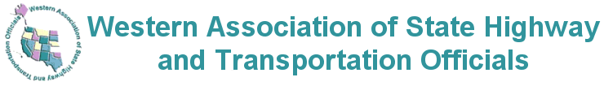
Committee on Highway Transport Meeting
Oklahoma City, OK
Meeting November 17-18, 2021
Travel Days November 16/19, 2021
Registration Form
Name |  | Title
Agency/Business

Street Address | City |  | State | Zip Code
Phone |  | E-mail
Date/Arrival |  | Date/Departure

HOTEL
Aloft Downtown
209 North Walnut Avenue
Oklahoma City, OK 73104
Phone 405-605-2100

Hotel Rate is $105 (plus taxes)
Parking $17 per day
Meeting Registration fee for WASHTO Fall Meeting $100
Fee is nonrefundable (Do not mail or fax credit card information)

Email this registration form to:
bmarten@mt.gov
Phone: 406-439-0700

